How to Install a Chain Link Fence in 5 Easy Steps

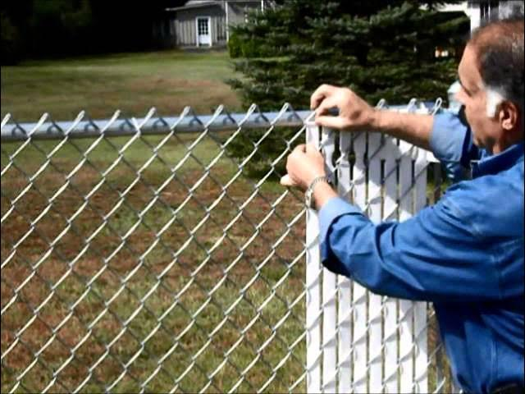

Steel walls are utilitarian and sturdy, however they frequently need stylish allure. Nonetheless, with a dash of innovativeness and exertion, you can transform these plain fences into eye-getting highlights that upgrade the magnificence of your outside space. Beneath, we investigate ten creative plans to hoist the vibe of a steel wall and make it a champion component in your finishing.

1. Add Lively Plants and Vegetation

A lavish presentation of plants can change a steel [Chain Link Fence](https://kennerfencecompany.com/custom-fence-installation-kenner/) wall into a characteristic show-stopper. Think about these methodologies:

Climbing Plants: Plant quickly developing climbers like jasmine, clematis, or morning brilliance. These plants wind through the wall, mellowing its brutal lines and adding vegetation.

Vertical Nurseries: Connect grower or pocket-style holders to the wall and grow a blend of blossoms, spices, and even vegetables. This strategy transforms your wall into a flourishing vertical nursery.

Hanging Grower: Utilize brilliant pots with snares to drape plants at different levels along the wall for a dynamic, layered impact.

2. Introduce Security Screens

Upgrading protection doesn't mean forfeiting style. Look over these choices:

Wooden Braces: Connect wooden supports on a level plane or in an upward direction to the wall for a contemporary look. Pick a characteristic completion or paint them to match your stylistic layout.

Bamboo Boards: Bamboo is lightweight and eco-accommodating, offering a fascinating stylish that matches well with plant life.

Texture Boards: Climate safe outside textures in strong varieties or examples can give your wall a new, current feel.

3. Paint It with Strong Tones

A new layer of paint can do some incredible things for any steel wall. Choose:

Splendid Shades: Tones like turquoise, yellow, or coral add energy and character.

Nonpartisan Shades: Assuming you incline toward inconspicuous class, think about dim, dark, or white.

Examples and Plans: Get innovative with stencils to paint mathematical examples, paintings, or botanical plans straightforwardly onto the wall.

4. Utilize Beautifying Supplements

Change the design of the wall by adding embellishing components. Famous choices include:

Security Braces: Vinyl or aluminum supports are accessible in different varieties and surfaces, offering a cleaned look while obstructing perceivability.

Metal Boards: Laser-cut metal additions with multifaceted examples can be woven into segments of the wall for an upscale, imaginative impact.

Wood Intonations: Integrate wooden casings or cross sections for a warm, provincial appeal.

5. Enlighten with Lighting Highlights

Lighting can make an otherworldly climate while making the wall a utilitarian piece of your night scene. Consider:

String Lights: Wrap pixie lights or Edison bulbs around the wall for a comfortable, welcoming mood.

Sun based Lights: Introduce sun powered fueled spotlights or pathway lights along the foundation of the wall for an eco-accommodating choice.

Lights: Balance improving lamps at stretches along the wall to add a hint of refinement.

6. Append Creative Boards or Wall paintings

Transform your wall into a workmanship establishment:

Open air Material Craftsmanship: Join weatherproof material prints to make an exhibition like encounter.

Metal Fine art: Introduce embellishing metal figures or boards that line up with your own taste.

Paintings: Recruit a nearby craftsman or paint a painting yourself. The chain connections can go about as an exceptional material for conceptual or themed craftsmanship.

7. Reuse Regular Articles

Consolidate reused materials to give your wall an unmistakable look:

Bottle Nurseries: Hang brilliant glass or plastic jugs loaded up with little plants or pixie lights.

Wind Tolls: Join custom made or locally acquired breeze rings for a mitigating, melodic touch.

Reflect Inflections: Secure little mirrors to make an intelligent, light-upgrading highlight.

8. Make a Living Wall

For a wall that mixes flawlessly with nature:

Supports: Plant fences close by the wall for a lavish, green limit. Over the long run, they can develop to completely conceal the wall.

Greenery Walls: Join boards of safeguarded greenery for a finished, eco-stylish look.

Delicious Casings: Organize succulents in edges and mount them wavering for a low-support living craftsmanship piece.

9. Consolidate Utilitarian Increments

Make your wall both wonderful and viable:

Open air Racking: Add racks to hold pruned plants, lights, or enhancing things.

Bicycle Racks: Introduce snares or racks to store bikes perfectly against the wall.

Capacity Compartments: Utilize weatherproof boxes joined to the wall for instruments, toys, or garden supplies.

10. Fabricate a Point of convergence Around It

Feature the wall as a component of a bigger scene plan:

Arbors and Doors: Edge the wall with arbors or resplendent entryways for a terrific entry.

Water Highlights: Position a wellspring, lake, or cascade close by to draw consideration.

Seating Regions: Make a comfortable corner with seats or a swing to cause the wall to feel like a necessary piece of the outside living space.]

End

Steel walls don't need to be a blemish. With just the right amount of imagination and exertion, they can become shocking elements that improve the general stylish of your property. Whether you favor a characteristic look, lively varieties, or utilitarian increments, there are vast ways of customizing your wall. By executing these thoughts, you can make your open air space interestingly yours and transform a plain steel wall into a plan work of art.